|  |  |
| --- | --- |
|  | AUSTRALIAN HIGH COMMISSION  DHAKA |

**23 January 2014**

**Australia Awards Alumni Association Bangladesh Warms Dhaka’s Needy to Mark Australia Day**

To mark Australia Day on 26 January, the Australia Awards Alumni Association Bangladesh (A4B) will distribute blankets and warm clothes to the underprivileged around the Dhaka metropolitan area. The association has collected contributions from its members.

The Australian Department of Foreign Affairs and Trade (DFAT) has matched in financial donations the contributions collected by the alumni which will be used to purchase blankets to support the association’s initiative. Mr. Rahman thanked the Australian High Commissioner to Bangladesh, the Honorable Mr Greg Wilcock, for the Australian Government’s contribution and its continued support to Bangladesh.

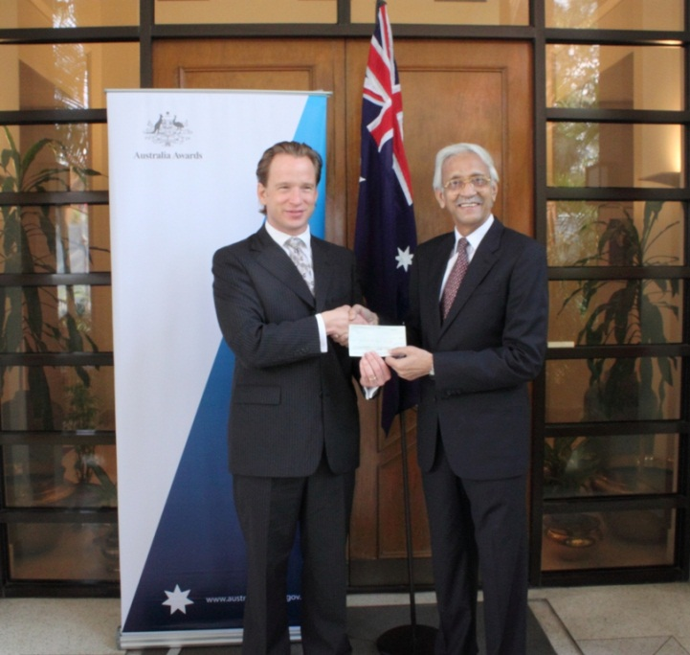

*High Commissioner Greg Wilcock handing over a DFAT contribution cheque to the Chair of the Australia Awards Alumni Association Bangladesh (A4B)*

“We were overwhelmed at the spontaneous response that we received from the members of A4B. The members were very happy to contribute to help the underprivileged people of Dhaka on the occasion of Australia Day”, said Mr Muhammad Saidur Rahman, the Chair of the Alumni Ad Hoc Committee. He thanked the members of the association for coming forward and said that the contributions from the members would certainly make a big difference to the lives of the needy.

A4B brings together Bangladeshis who studied in Australia under Australia Award Scholarships and returned to contribute to the development of Bangladesh. Each year the Australian Government provides scholarships opportunities to Bangladeshi nationals to undertake tertiary level studies at Australian universities and institutions.

For further information please contact:

Senior Research and Communications Officer, AHC Dhaka

Tel: 8813105 (497); E-mail: simeen.sabha@dfat.gov.au